Brief Introduction of Medical School, Hubei Polytechnic University
Medical School was established in 2004 when the 30-odd year Department of Medicine, Huangshi Polytechnic College merged with the 80-odd year Hubei Secondary Health School. It is comprised of six departments including: Clinical Medicine, Traditional Chinese Rehabilitation, Nursing, Pharmacy, Medical Laboratory Tests and Imaging as well as Basic Medical Science. It offers two bachelor degree programs---Nursing and Pharmacy, 6 diploma programs---nursing, clinical medicine, pharmacy, rehabilitation therapy technology, medical imaging technology, medical laboratory tests technology.
It boasts 66 teaching staff with 8 professors, over 40 associate professors. Five of them have doctor degree and over 30 of them have master degree. It has a full-time student body of 1600.
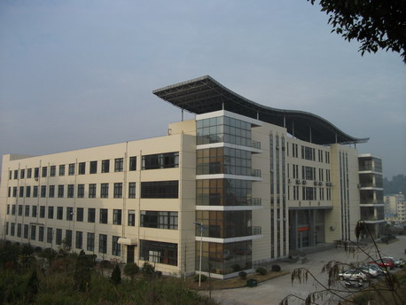
(The building where the Medical School is located, HSIT)
Medical school has two affiliated hospitals---Huangshi Central Hospital (a AAA hospital) and affiliated hospital of Hubei Polytechnic University, more than 20 teaching hospitals, one pharmaceutical enterprise which has passed the state GMP evaluation as well as one biological research institute. The medical school has a total construction area of 14000 m² and the total value of the facilities RMB 4.8 million. The discipline of pharmacy is one of the top priorities in the development of the disciplines in Hubei Polytechnic University, the Nursing program the college-level key program. In recent years, the medical school has completed more than 20 municipal, provincial or national scientific research projects, including one global fund project and one national natural science fund project. The faculty in the medical school have compiled and published 26 textbooks or reference books and published 350-odd academic papers. The employment rate of the graduates is over 85%. The majority of the graduates are working with urban hospitals and medium and large-scale pharmaceutical enterprises.

